香港閃避球夏季聯賽2022
Hong Kong Dodgeball Summer League 2022
成績公佈 Result
業餘組 Amateur’s Category 日期 Date: 7/2022-8/2022
冠軍 Champion | Donut
亞軍  1st Runner-up | Game of Throws
季軍  2nd Runner-up | Moon Knights
殿軍  3rd Runner-up | Cereal Thrillers
🏆最有價值球員 Most Valuable Player
Donut |  | Mok Tsz Yau
🏆擊殺王 Top Killer
Moon Knights |  | Chum Ming Chiu
🏆接殺王 Top Catcher
Moon Knights |  | Yeung Ming Sze
🏆季度最佳新人 Rookies of the season
Donut |  | Yau Chun Kit

香港閃避球夏季聯賽2022
Hong Kong Dodgeball Summer League 2022
成績公佈 Result
中級組 Intermediate’s Category 日期 Date: 7/2022-8/2022
冠軍 Champion | Donut 2.0
亞軍  1st Runner-up | Greenery Intermediate
季軍  2nd Runner-up | BU Animal Yokocho
殿軍  3rd Runner-up | Your hk night
🏆最有價值球員 Most Valuable Player
Donut 2.0 |  | Chan Chun Hin
🏆擊殺王 Top Killer
BU Animal Yokocho |  | Lai Nok Hin
🏆接殺王 Top Catcher
Donut 2.0 |  | Tam Kalle
🏆季度最佳新人 Rookies of the season
Greenery Intermediate |  | Tsang Yam Yuen

香港閃避球夏季聯賽2022
Hong Kong Dodgeball Summer League 2022
成績公佈 Result
新星組 Novice’s Category 日期 Date: 7/2022-8/2022
冠軍 Champion | Bu Bu Buuu
亞軍  1st Runner-up | Phoneix
季軍  2nd Runner-up | Death Horizon
殿軍  3rd Runner-up | EduHK Dodgeball
🏆最有價值球員 Most Valuable Player
Bu Bu Buuu |  | Tam Hoi Tung
🏆擊殺王 Top Killer
Phoneix |  | Lam Hon Leung
🏆接殺王 Top Catcher
EduHK Dodgeball |  | Cheung Ho Yin
🏆季度最佳新人 Rookies of the season
Phoneix |  | Chau Yee Pang

香港閃避球夏季聯賽2022
Hong Kong Dodgeball Summer League 2022
成績公佈 Result
女子組 Women’s Category 日期 Date: 7/2022-8/2022
冠軍 Champion | Donut
亞軍  1st Runner-up | BiubiubiU
季軍  2nd Runner-up | Greenery 2
🏆最有價值球員 Most Valuable Player
Donut |  | Chan Hoi Ching
🏆擊殺王 Top Killer
BiubiubiU |  | Man Tsz Shan
🏆接殺王 Top Catcher
BiubiubiU |  | Wong Yeuk Lan
🏆季度最佳新人 Rookies of the season
Donut |  | Yau Suet Tung

恭喜以上得獎隊伍及球員！ Congratulations !

香港閃避球夏季聯賽2021
Hong Kong Dodgeball Summer League 2021
成績公佈 Result
男子組 Men’s Category 日期 Date: 7/2021-8/2021
冠軍 Champion | Newbie Material
亞軍  1st Runner-up | Villagers
季軍  2nd Runner-up | Untouchaballs
🏆最有價值球員 Most Valuable Player
Newbie Material |  | Ho Sang Fai
🏆擊殺王 Top Killer
Villagers |  | Biong
🏆接殺王 Top Catcher
Sugar Daddy |  | Fung
Newbie Material |  | Johnny

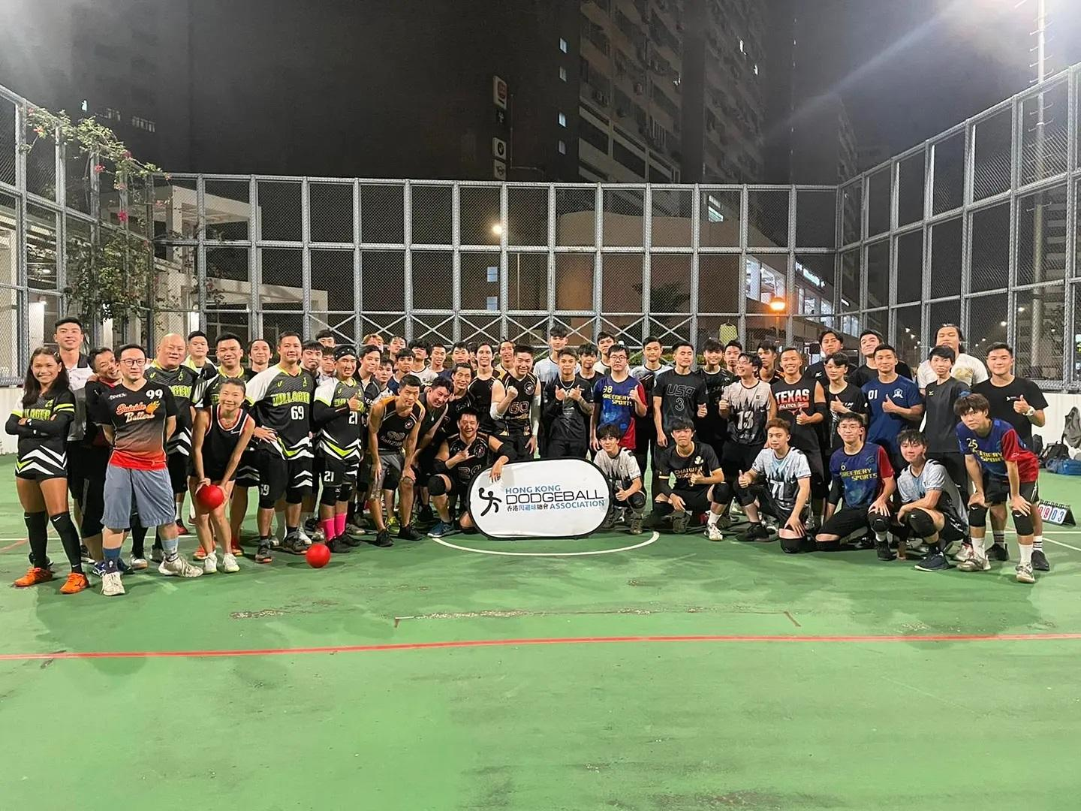

香港閃避球夏季聯賽2021
Hong Kong Dodgeball Summer League 2021
成績公佈 Result
女子組 Women’s Category 日期 Date: 7/2021-8/2021
冠軍 Champion | Dodgey Ladies
亞軍  1st Runner-up | Ball Sniper
季軍  2nd Runner-up | Team OA
🏆最有價值球員 Most Valuable Player
Ball Sniper |  | MeiYan Cheung
🏆擊殺王 Top Killer
Ball Sniper |  | Janice So
🏆接殺王 Top Catcher
Dodgey Ladies |  | Pammy Chan

恭喜以上得獎隊伍及球員！ Congratulations !

